Daniel Prusinski
Predict 412
Appendix 1: Graphics in R
Plot(wine) Function
Scatter 1

Scatter Plot 2

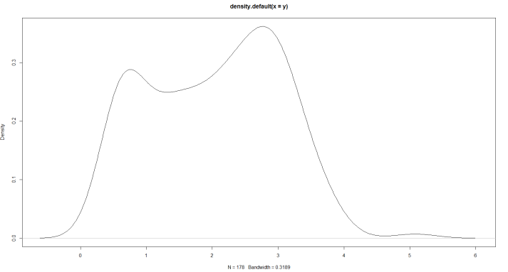
The density plot highlights the distribution of data points for the variable of Flav. 3
Scatter Plot Matrix Graphic:4

Graphic 5: Density Plots – Alcohol, Malic Acid, Ash, AlcAsh

Graphic 6: Density Plots – Mg, Phenols, Flav, NonFlavPhenols

Graphic 7: Density Plots – Proa, Color, Hue, OD

Graphic 8: Density Plots – Proline

Graphic 9: Box Plots: Top Left (1= Malic, 2= Ash, 3= Phenols, 4= Flav, 5= Proa, 6= OD)
Top Right (1= Alcohol, 2=AlAsh, 3= Color) Bottom Left (Proline) Bottom Right: 1=NonFlaPhe, 2=Hue

Output 10: Box Plot (MG)

